- When the user signs up, he will check the tab password or confirm password. And one more think is that when signup is not done then in my backend SQL query is not store data in my Table.
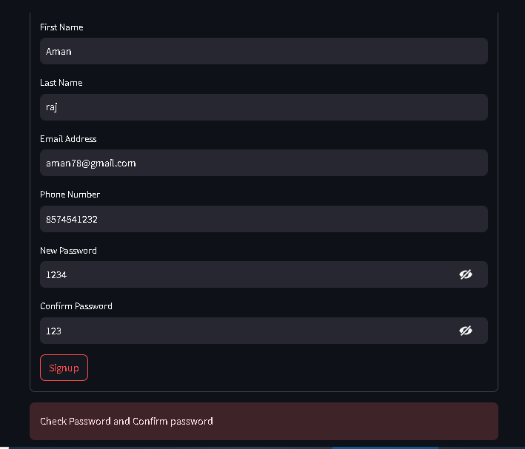

- When is user signup suceesfully this . Then my data is stored in my data in my table.
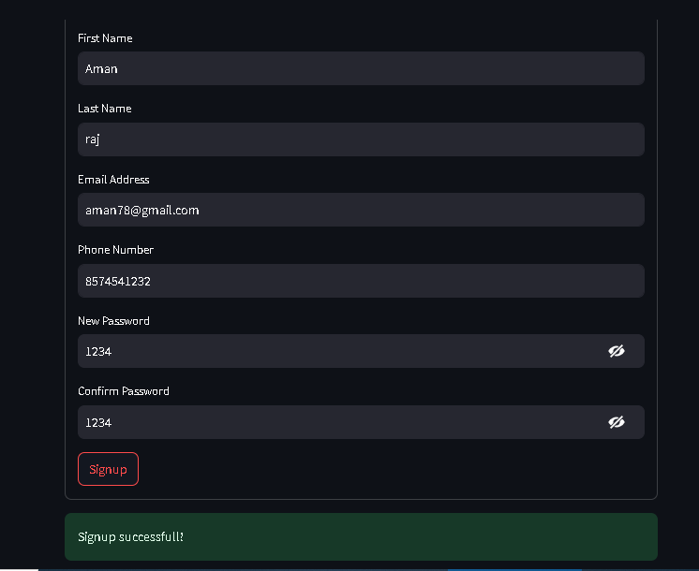

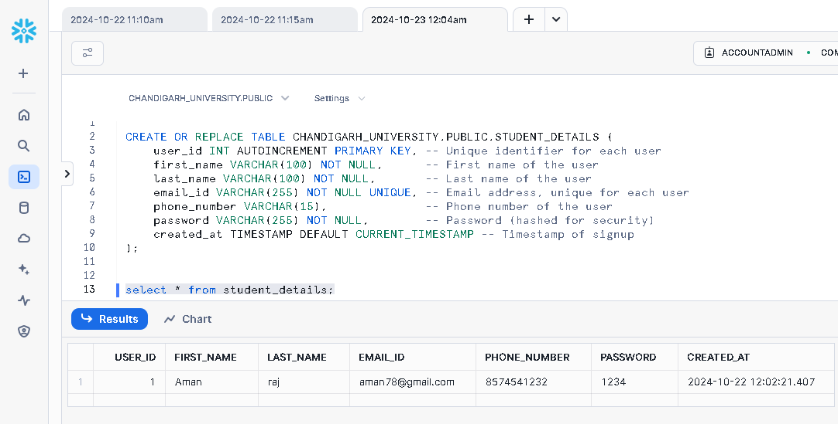
- User are login when Email and Password are store in my table . User will go to login his own Email and password then Show to the user invalid username and password.
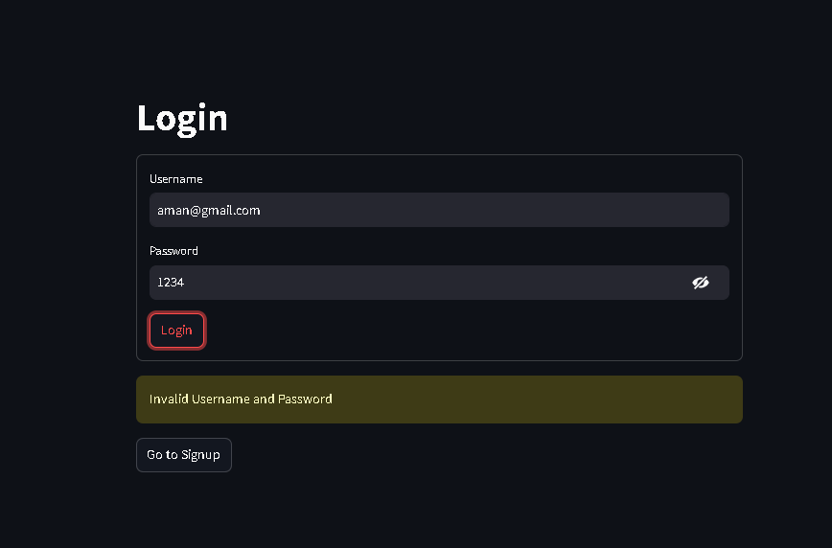

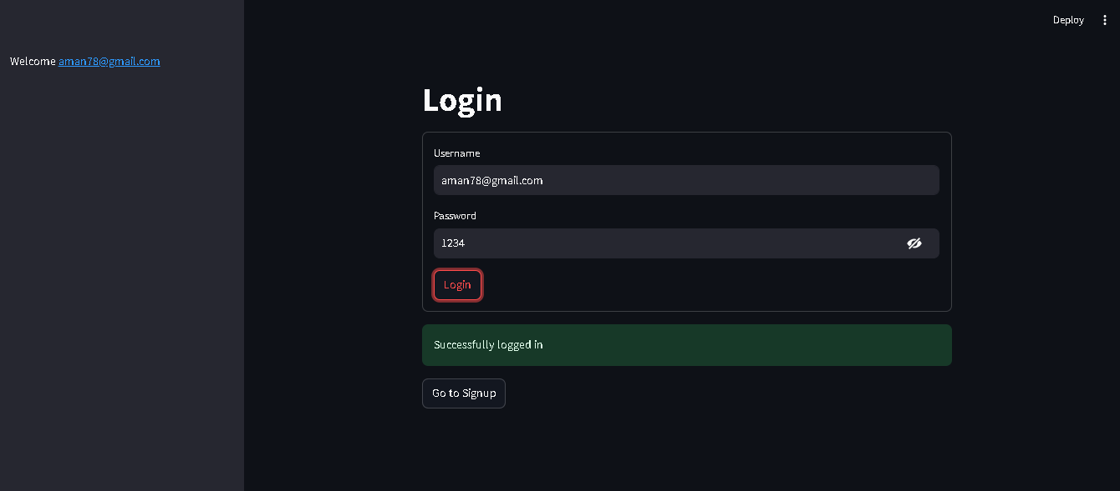
- User is write a right Email and Password then will show login successfully

